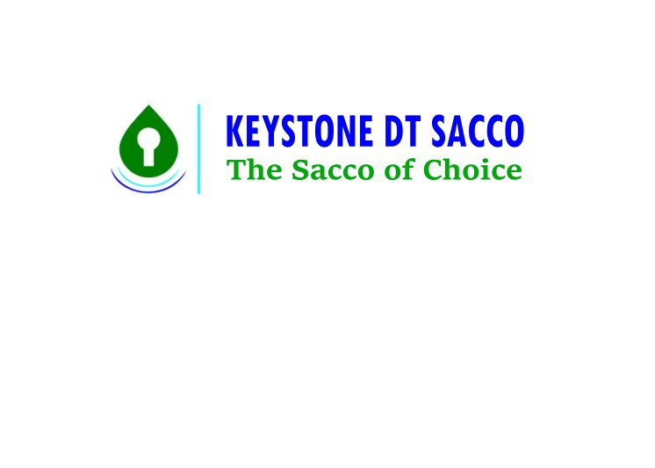

**P.O BOX 2073, TEL (057) 2024767, MOBILE: 0799946225, KISUMU – KENYA**

**Email: keystonedtsacco@gmail.com, info@keystonedtsacco.co.ke Web: www.keystonedtsacco.co.ke**

**REQUEST FOR BANKERS CHEQUE FORM**

DATE:…………………………………………………..

NAME:………………………………………………………………………………………………………………………………………..

MNO:………………………………………………. TSC/P.F NO:……………………………………………………………………..

ID NO:……………………………………………….

Dear Sir/Madam

**RE: BANKERS CHEQUE**

I hereby authorize you to debit my savings account number …………………………………………………….. With Kshs………………………………………………………… in words……………………………………………………………

…………………………………………………………………………………………………………………………………………………….

Plus any commissions that may be levied in regard of the cheque and issue me with banker’s cheque(s) in favor of the following:

Payee…………………………………………………………………. Amt…………………………………………………

Payee…………………………………………………………………. Amt…………………………………………………

Payee…………………………………………………………………. Amt…………………………………………………

Payee…………………………………………………………………. Amt…………………………………………………

TOTAL:………………………………………......

Signature:…………………………………………………………..

**For official use**

**Cheque Nos issued………………………………………….. Amt………………………………………………….**

**Issued By………………………………………………………… Sign…………………………………………………..**

**Authorized By………………………………………………… Sign…………………………………………………..**

**Collected By…………………………………………………… Sign…………………………………………………….**